Outcome
The outcome of procedure is to successfully backup a Data Lake Storage.
Prerequisites
The following are prerequisites for the successful completion of this procedure:
- Approved change within BMC Helix with appropriate notes attached to the change.
- One Azure SQL Database to host the metadata table for the ADF metadata Task.
- A linked Service in ADF with a successful connection to the database.
- Source and Sink Azure Data Lake Gen 2 resources with storage contributor permissions at the minimum.
- Linked services to the source and sink storage account(s).

Actions

There are Two Methods that can be used to Backup Data Lake:
Using ADF
Using Vaulted Backup (Option Still in Preview Stage)
Generate the ADF pipelines
In the ADF Author hub, launch the Copy Data Tool as shown below.
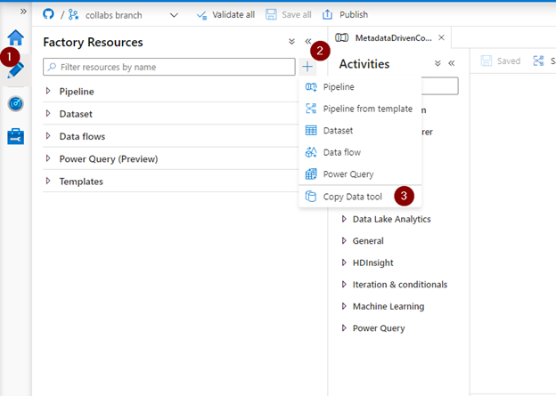
- In the properties page, select the Metadata-driven copy task type. You will be prompted to select a linked service to host the control table. The control table will be used to maintain metadata for the copy activity – the source storage account, the source container, the target storage account, etc. – and can be created in a Azure SQL DB or Synapse Analytics instance. Note that during the preview, you might need to apply minor changes to the script generated to create the table in Synapse. For this walkthrough, we’ll use an Azure SQL Database to host the meta data properties.
- Choose an existing linked service or create a new one to the Azure SQL Database. After you select the linked service, new text boxes will appear for the schema and the name of the control table.
- Select an existing table or create a new one by checking on the Create new table option.
- Specify the task cadence or task schedule and provide appropriate values.
- Click on Next to move to the next step
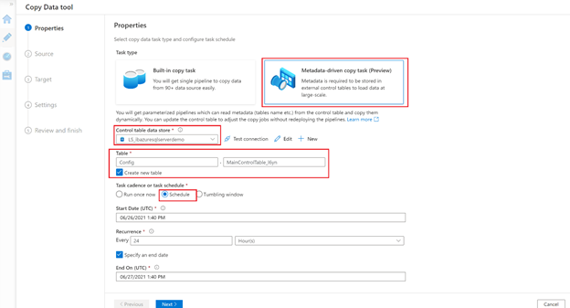
- Now we’ll provide the connection details of our data source.
- Many source types are supported. In our case, we’ll choose Azure Data Lake Storage Gen 2.
- Select an existing linked service to the source storage or create a new one.
- Click on the Browse button to select the container and/or folder you want to backup.
- As mentioned above, we create a full backup once a month and an incremental backup on a daily basis. Select Incremental Load for the File loading behaviour. This will generate an entry in the control table for the incremental load. We’ll manually create another entry for the full load.
- As this is a backup, we do not need to read the content of the files, so we’ll select a Binary copy behaviour.
- Select Next.
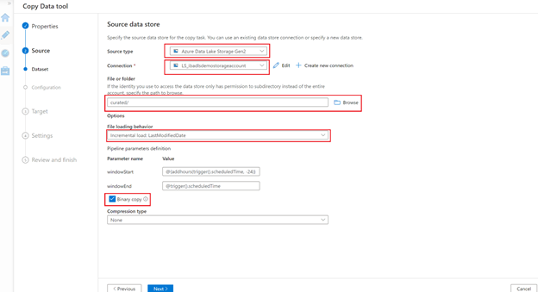
- In the Destination data store page, specify the properties of the target storage account.
- Choose the destination target type as Azure Data Lake Storage Gen2.
- Select an existing linked service to the target storage or create a new one.
- Click on the Browse button to select the backup container.
- Select the ‘Preserve Hierarchy’ copy behaviour to keep the folder structure ‘as-is’ from source to sink.
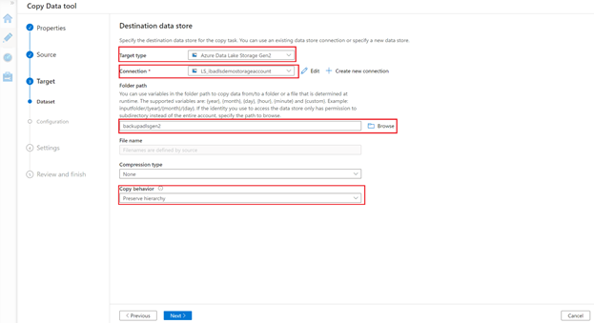
- Provide the Task Prefix name on the Settings step. Under Advanced Settings, you can select options like Data Consistency Verification, Fault Tolerance, Preserving the ACLs and many more.
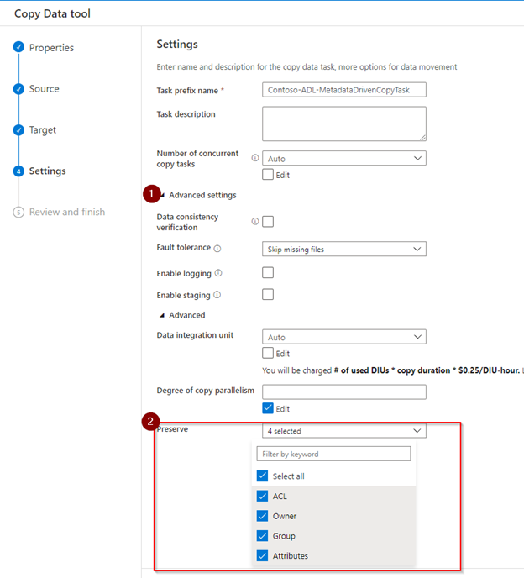
- Review and validate your set up in the summary page and make sure it all looks good, then proceed by clicking Next.
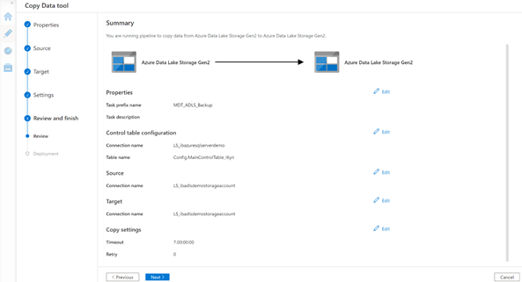
- In the Deployment step, the following are created:
- The ADF pipelines for the backup.
- Source, target and control datasets.
- The SQL script to create the control tables and insert the parameters for the incremental load.
Copy the SQL script and run against the Azure SQL database (the same database we used as the control table store) using your favourite client tool – Management Studio, Azure Data Studio or even the Query Editor option in the Azure portal. You also have the option to download the script, if needed.
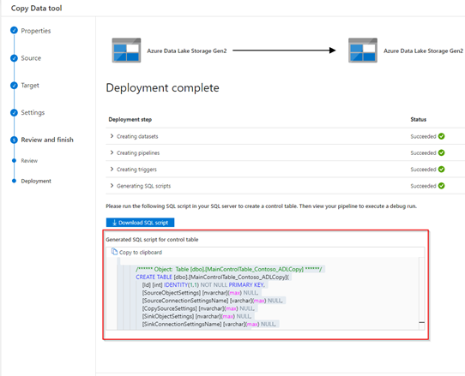
Go back to the authoring hub in ADF to view the generated pipelines and datasets.
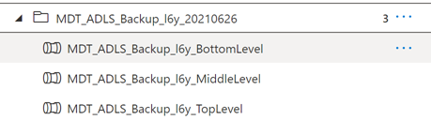
As you can see, three pipelines are generated:
- Top level Pipeline: <Task_Prefix_Name>_TopLevel
This pipeline counts the total number of objects (tables etc.) to be copied in this run, determines the number of sequential batches based on the maximum allowed concurrent copy task instances, and then executes another pipeline to copy different batches sequentially.
- Middle level Pipeline: Task_Prefix_Name>_MiddleLevel
This pipeline copies one batch of objects. The objects belonging to this batch will be copied in parallel.
- Bottom level pipeline: MetadataDrivenCopyTask_xxx_ BottomLevel
This pipeline copies objects from one group. The objects belonging to this group will be copied in parallel.

Configure vaulted backup for Azure Data Lake Storage using Azure portal (preview)

Prerequisites
Before you configure backup for Azure Data Lake Storage, ensure the following prerequisites are met:
- The storage account must be in a supported region and of the required types.
- The target account mustn't have containers with the names same as the containers in a recovery point; otherwise, the restore operation fails.

Create a Backup vault
To back up Azure Data Lake Storage, ensure you have a Backup Vault in the same region. You can use an existing vault, or create a new one.
Create a backup policy for Azure Data Lake Storage (preview)
A backup policy defines the schedule and frequency for backing up Azure Data Lake Storage. You can either create a backup policy from the Backup vault, or create it on the go during the backup configuration.
To create a backup policy for Azure Data Lake Storage from the Backup vault, follow these steps:
- In the Azure portal, go to the Backup vault > Backup policies, and then select + Add.
- On the Create Backup Policy pane, on the Basics tab, provide a name for the new policy on Policy name, and then select Datasource type as Azure Data Lake Storage (Preview).
- On the Schedule + retention tab, under the Backup schedule section, set the Backup Frequency as Daily or Weekly and the schedule for creating recovery points for vaulted backups.
- Under the Add retention section, edit the default retention rule or add new rules to specify the retention of recovery points.
- Select Review + create.
- After the review succeeds, select Create.
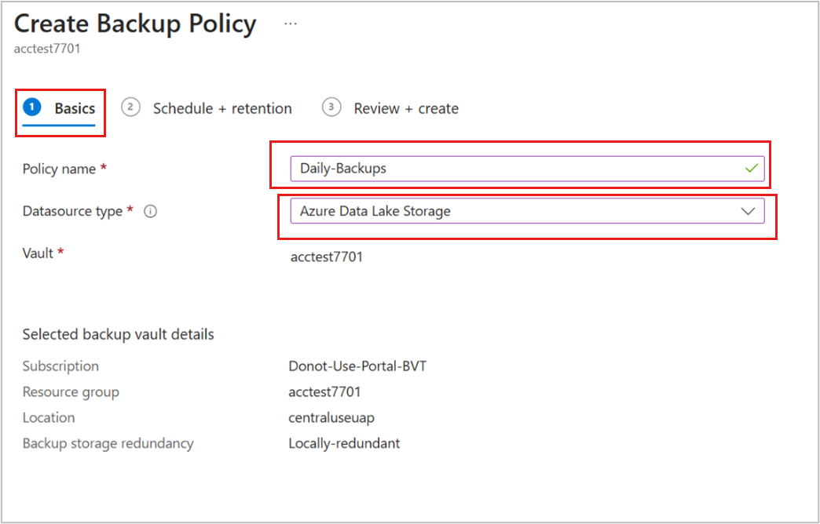
Grant permissions to the Backup vault on storage accounts
A Backup vault needs specific permissions on the storage account for backup operations. The Storage Account Backup Contributor role consolidates these permissions for easy assignment. We recommend you to grant this role to the Backup vault before configuring backup.
Note
You can also perform the role assignment while configuring backup.
To assign the required role for storage accounts that you want to protect, follow these steps:
Note
You can also assign the roles to the vault at the Subscription or Resource Group levels according to your convenience.
- In the Azure portal, go to the storage account, and then select Access Control (IAM).
- On the Access Control (IAM) pane, select Add role assignments to assign the required role.
- On the Add role assignment pane, do the following steps:
  - Role: Select Storage Account Backup Contributor.
  - Assign access to: Select User, group, or service principal.
  - Members: Click + Select members and search for the Backup vault you created, and then select it from the search result to back up blobs in the underlying storage account.
- Select Save to finish the role assignment.
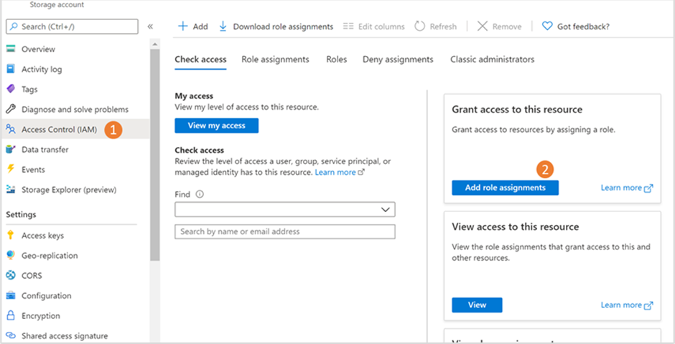
Note
The role assignment might take up to 30 minutes to take effect.
Configure backup for the Azure Data Lake Storage (preview)
You can configure backup on multiple Azure Data Lake Storage.
To configure backup, follow these steps:
- In the Azure portal, go to the Backup vault, and then select + Backup.
- On the Configure Backup pane, on the Basics tab, review the Datasource type is selected as Azure Data Lake Storage (preview).
- On the Backup policy tab, under Backup policy, select the policy you want to use for data retention, and then select Next. If you want to create a new backup policy, select Create new. learn how to create a backup policy.
- On the Datasources tab, SelectAdd.
- On the Select storage account container pane, provide the Backup instance name, and then click select under Storage account.
- On the Select hierarchical namespace enabled storage account pane, select the storage accounts with Azure Data Lake Storage across subscriptions from the list that are in the region same as the vault.
- On the Select storage account container pane, you can back up all containers or select specific ones.
After you add the resources, backup readiness validation starts. If the required roles are assigned, the validation succeeds with the Success message.
If access permissions are missing, error messages appear. See the prerequisites.
Validation errors appear if the selected storage accounts don't have the Storage Account Backup Contributor role. Review the error messages and take necessary actions.
ErrorCauseRecommended actionRole assignment not doneThe Storage account backup contributor role and the other required roles for the storage account to the vault are not assigned.Select the roles, and then select Assign missing roles to automatically assign the required role to the Backup vault and trigger an auto revalidation.
If the role propagation takes more than 10 minutes, then the validation might fail. In this scenario, you need to wait for a few minutes and select Revalidate to retry validation.
You need to assign the following types of permissions for various operations:
- Resource-level permissions: For backing up a single account within a resource group.
- Resource group or Subscription-level permissions: For backing up multiple accounts within a resource group.
- Higher-level permissions: For reducing the number of role assignments needed.
Note that the maximum count of role assignments supported at the subscription level is 4,000. Learn more about Azure Role-Based Access Control Limits.Insufficient permissions for role assignmentThe vault doesn't have the required role to configure backups, and you don't have enough permissions to assign the required role.Download the role assignment template, and then share with users with permissions to assign roles for storage accounts.
- Review the configuration details, and then select Configure Backup.
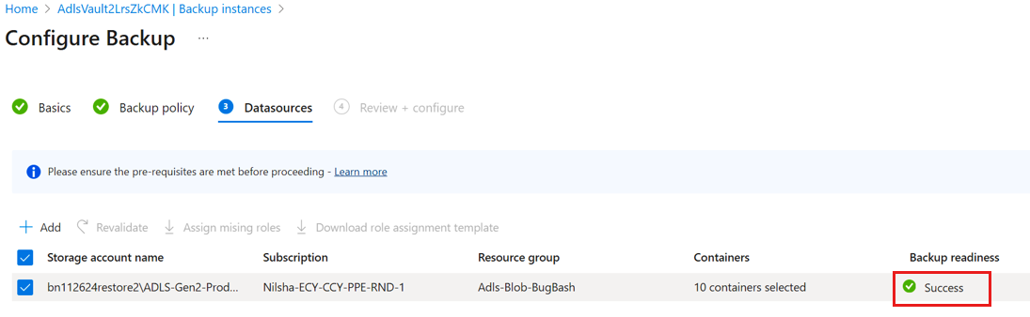
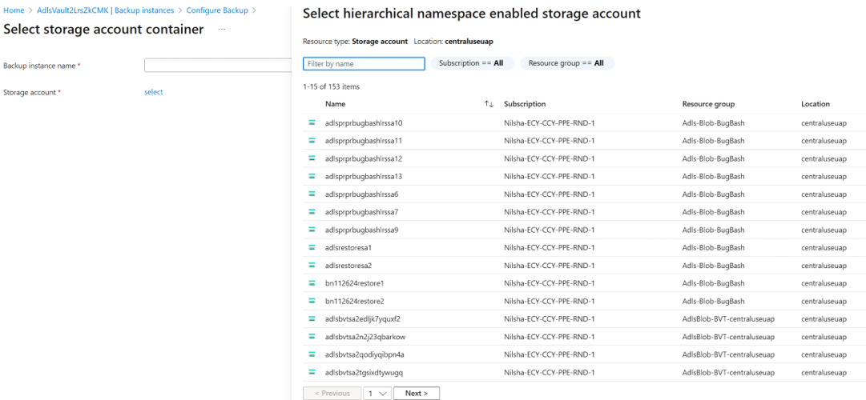
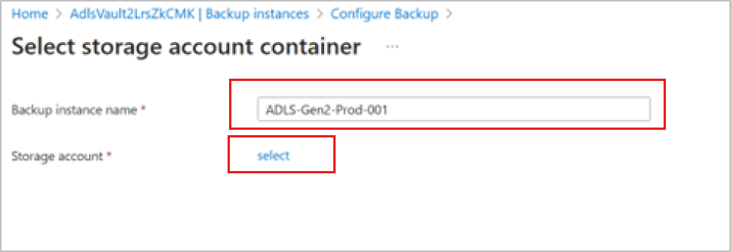
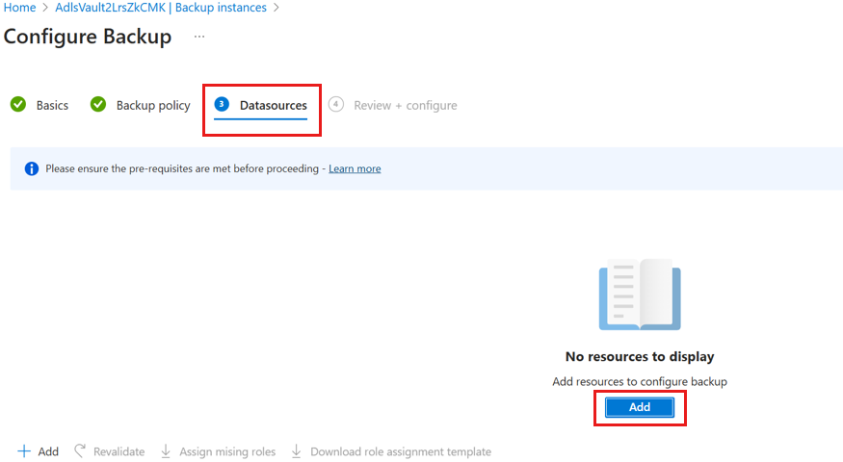
You can track the progress of the backup configuration under Backup instances. After the configuration of backup is complete, Azure Backup triggers the backup operation as per the backup policy schedule to create the recovery points.

Restore the storage data from vaulted backups
o restore Azure Data Lake Storage from vaulted backups, follow these steps:
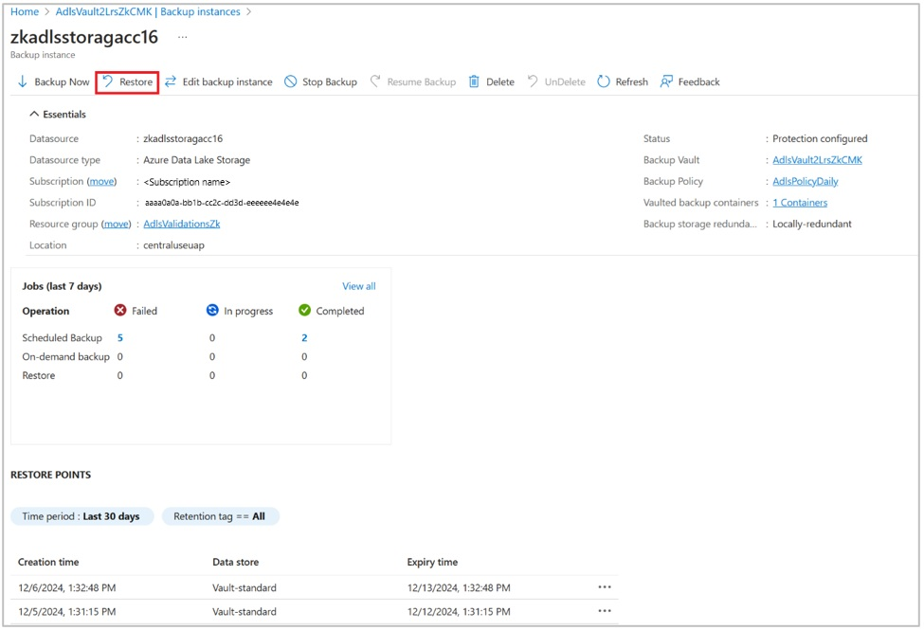
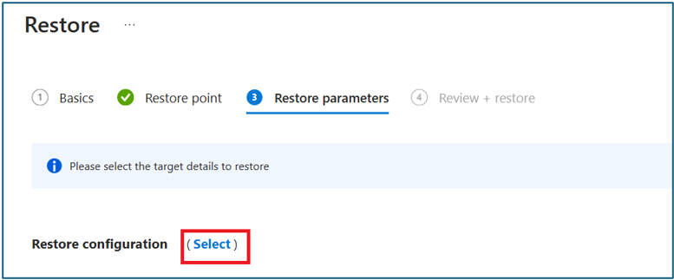
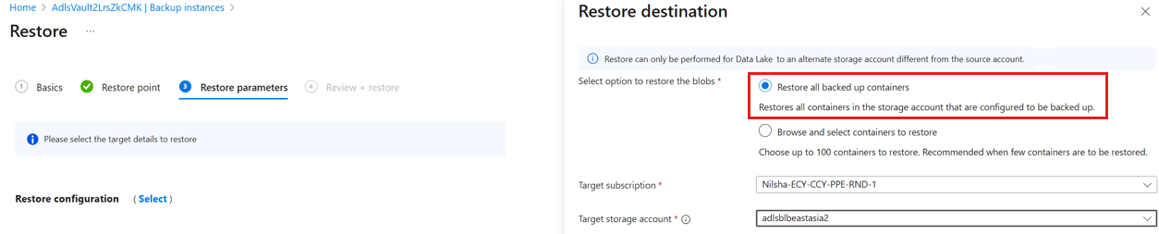
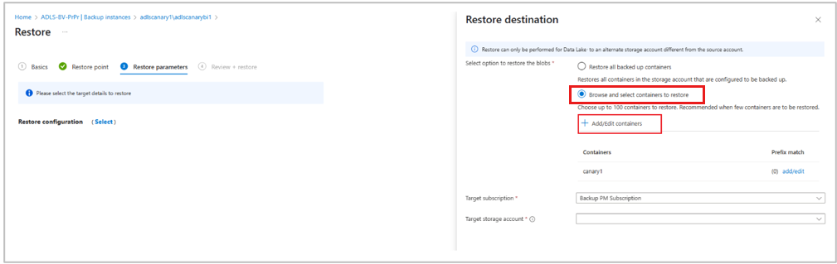
- In the Azure portal, go to the Backup vault, and then select Backup Instances.
- On the Backup Instances pane, select the storage account with Data Lake Storage, and then select Restore.
- On the Restore pane, on the Restore point tab, click Select restore point. By default, the latest restore point is selected.
- On the Select restore point pane, select the required restore point from the list.
- On the Restore pane, on the Restore parameters tab, specify the restore configuration parameters by clicking Select.
- On the Restore destination pane, under Select option to restore the blobs, select one of these options:
  - Restore all backed-up containers: This option restores all backed-up containers in the storage account. Select the Target subscription in which the target storage account is present, and then select Target storage account where the data needs to be restored.
  - Browse and select containers to restore: This option allows you to browse and select up to 100 containers to restore. (Optional) Specify a set of prefixes to restore specific blobs within a container. To provide the list of prefixes, select Add/Edit containers corresponding to each container that you select for restore.
  - On the Restore parameters tab, select Validate to ensure that the required permissions to perform the restore are assigned to the backed-up storage accounts with Data Lake selections.
If the validation fails, select Assign missing roles to grant permissions. See the prerequisites for the required roles.
- After the validation succeeds, select Review + restore and restore the backups to the selected Data Lake Storage.
- On the Review + restore tab, select Restore to start the restore operation.
Confirmation
Detail the list of actions to be carried out to confirm the procedure was a successful in delivering the outcome. Please note a sample email template is provided below. If the procedure requires interaction with a customer, then the email template should be tailored to suit the procedure. If there is no interaction, then delete the email template. The important things to note in your communication are the following: Return emails to be sent to OS-IS-SD-HCL-DATA. Your name is NOT to be included in the email salutation.
Send a confirmation email to the requester to confirm that the desired outcome has been achieved:
Email Subject: <CHANGE NUMBER> - <OBJECTIVE OF CHANGE>
Email Note:
Hi <CUSTOMER NAME>,
We have completed the above change having performed the <OBJECTIVE OF CHANGE>.
Could you please confirm the activity was performed successfully to meet your
requirements.
Please direct your response back to this email to OS-IS-dddataengineering@brisbane.qld.gov.au.
Regards
Data Team

Rollback
Detail the list of actions to be followed to rollback the outcome of the procedure if the confirmation proves the procedure did not produce the desired outcome.

Known Errors
Document any errors and associated workarounds witnessed through the use of this procedure. This is required to provide a history of errors for this procedure to support future reviews of this procedure and better inform future executions.
Below is a list of known errors experienced with the use of this procedure.
Symptom | Confirmation Action | Support References
- The Symptom column lists text that may appear in alert logs or may describe errant behaviour of affected functionality.
- The Confirmation Action Column is a list of actions/scripts you can run to confirm the known error applies to your circumstance.
- The Support References Column provides a list of tags that can be searched in the various support portals to identify workarounds or patches to be applied.
Introduce a link to the known errors page for the underlying technology below.
The known errors associated with the underlying technology can be found here

